

Lab Assignment/Task Report
Only for course Teacher
 |  | Needs Improvement | Developing | Sufficient | Above Average | Total Mark
Allocate mark & Percentage |  | 25% | 50% | 75% | 100%
Clarity
Content Quality
Spelling & Grammar
Organization and Formatting
Total obtained mark
Comments

Semester: Fall 2026
Student Name: Shahriar Salman
Student ID: 26010168
Batch: 46 Section: B
Course Code: CSE 124 Course Name:
Course Teacher Name: Object Oriented Programming
Designation: Lecturer
Submission Date: 30/ 07 / 2026
1. Hello and Name Printer
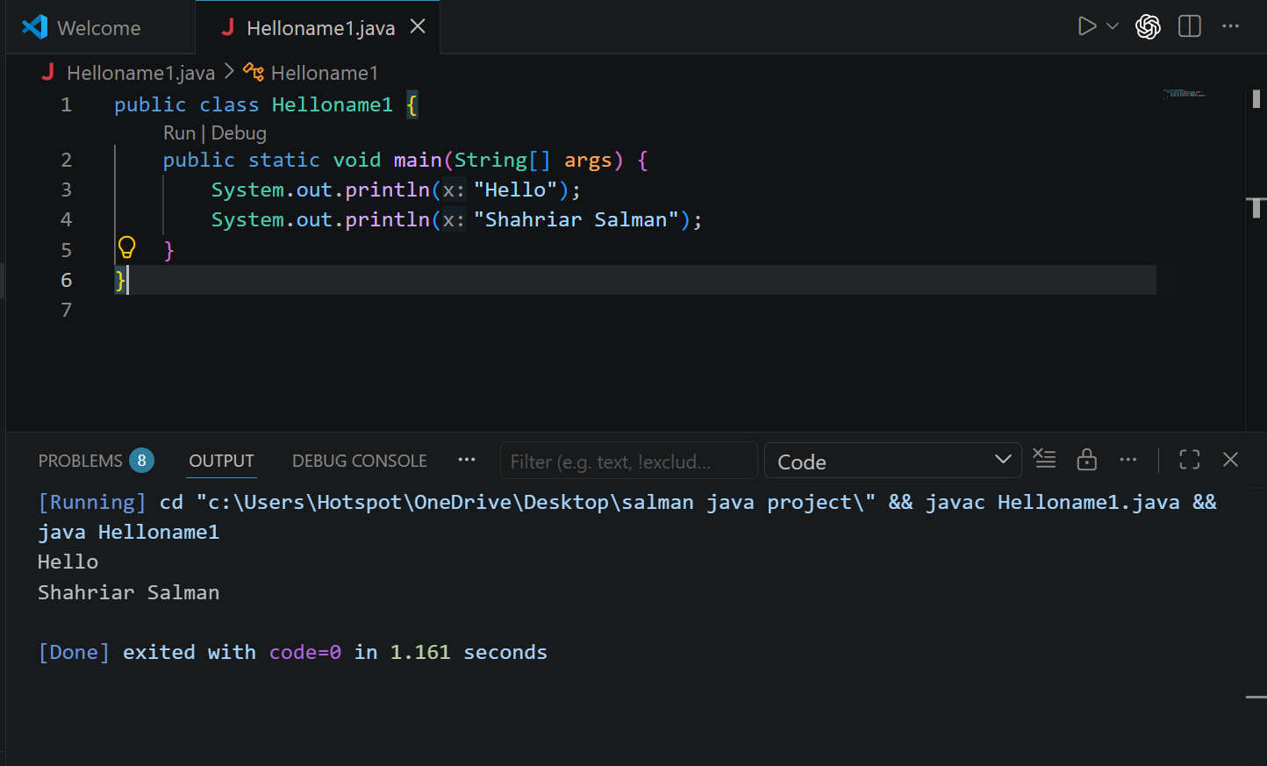

Explanation: This program prints "Hello" and the user's name on separate lines using

2. Sum of Two Numbers
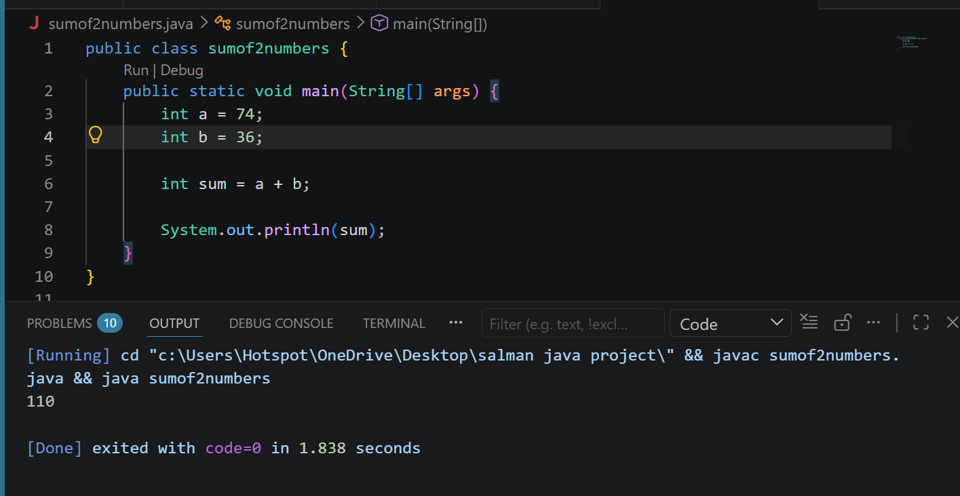
ExplanationThis program stores two numbers in variables, adds them, and prints the sum.

3. Division of Two Numbers

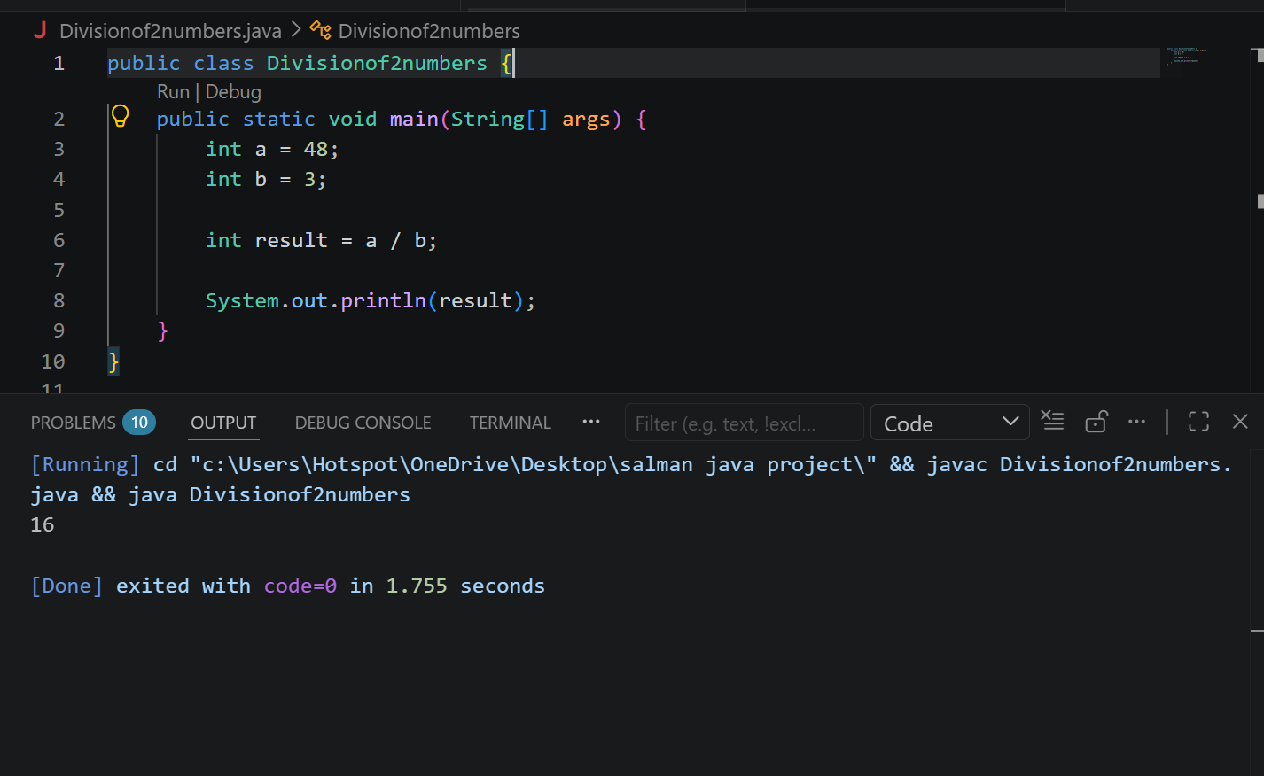

Explanation:This program divides one integer by another and prints the quotient.

4. Arithmetic Operations

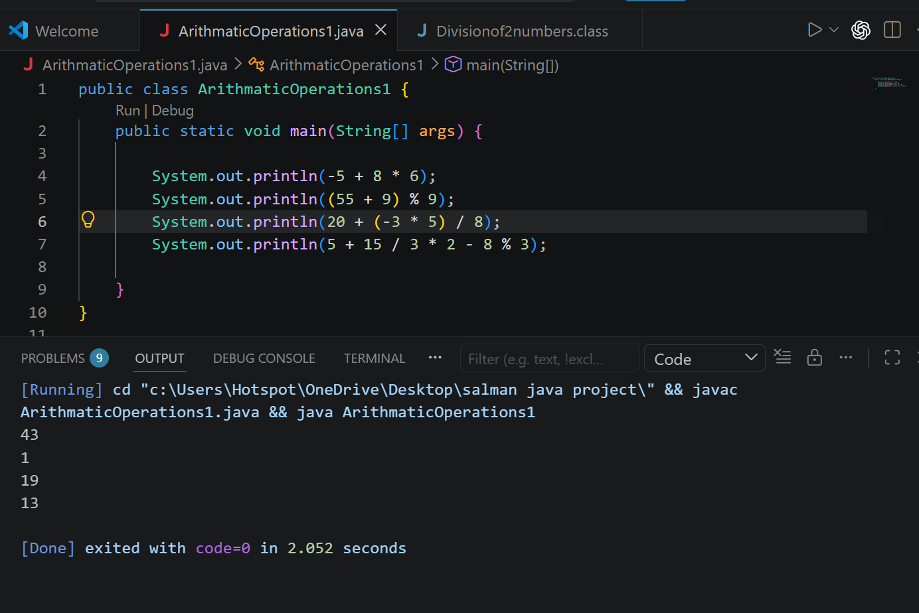
Explanation:
This program evaluates different arithmetic expressions and displays their results

5. Product of Two Numbers
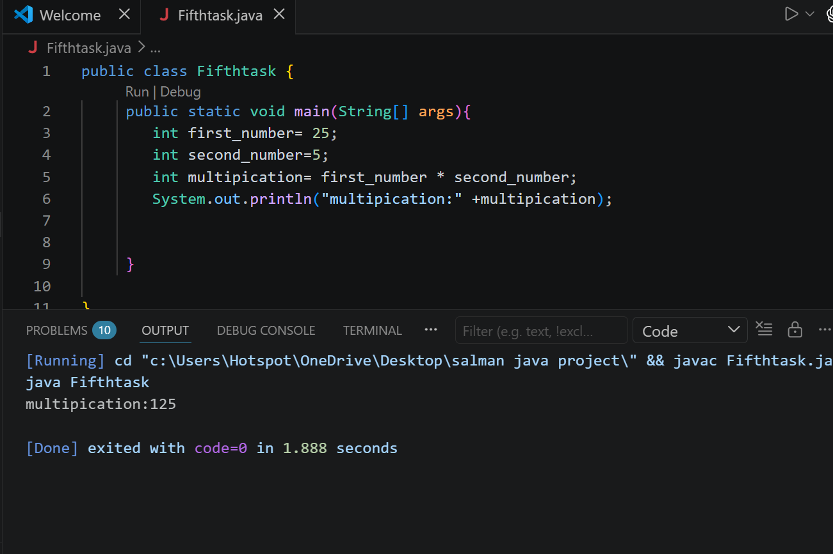
Explanation:
This program takes two numbers as input, multiplies them, and prints the product.

8. Pattern Display: JAVA
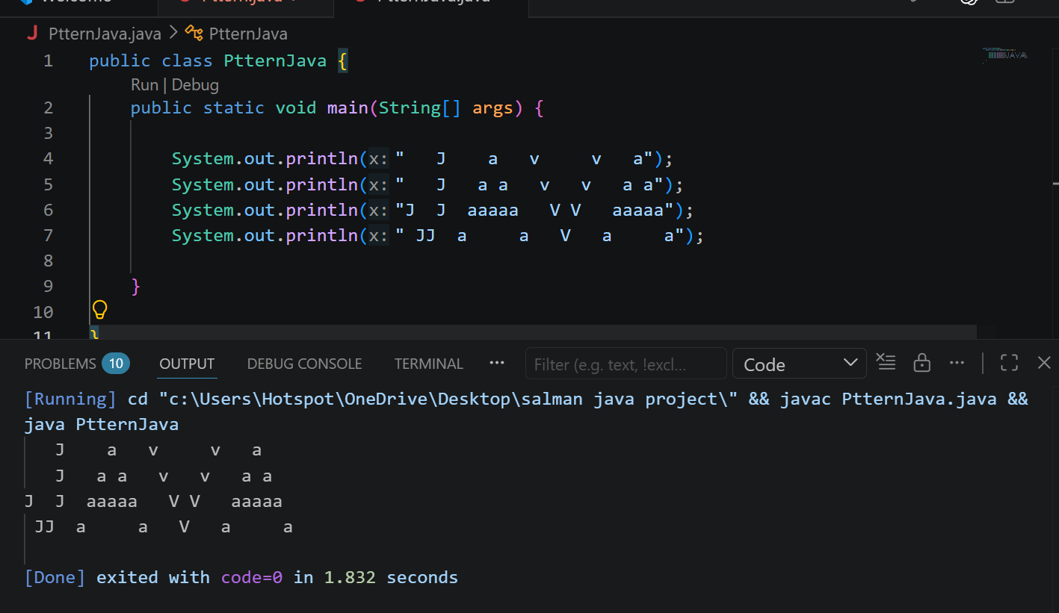

Explanation:
This program prints the word JAVA in a specific pattern using System.out.println()

10. Formula Computation
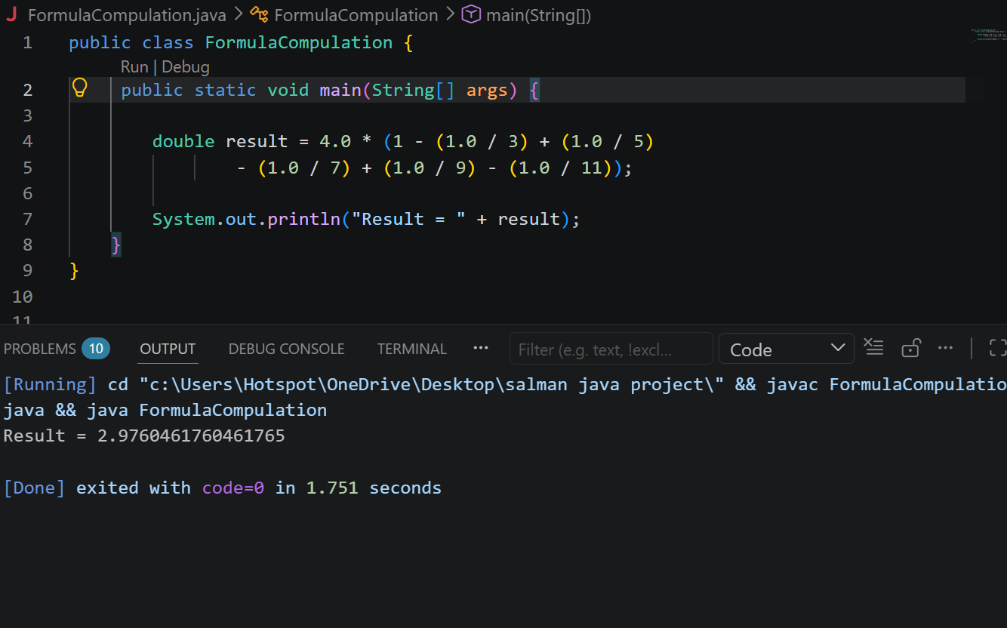
Explanation:
This program calculates the given mathematical formula using the double data type and prints the result.

